Need Analysis
Introduction
In most colleges, various student societies organize multiple events throughout the semester — from workshops and hackathons to cultural fests and club activities. However, despite their frequency and relevance, a large portion of students remain unaware of these opportunities due to inconsistent communication methods.
Currently, event information is shared through emails, WhatsApp groups, and social media, making it difficult for students to track all activities efficiently.
Uniconnect aims to address this gap by providing a centralized web platform for all event-related communication, registration, and analytics within the college.
Through this Need Analysis, we aim to understand the real challenges faced by students and societies, assess user expectations, and validate whether there is a genuine demand for such a solution.
Problem Context
At present, there is no unified system in place for event discovery or registration in most educational institutions. Societies rely on a mix of emails, posters, and group messages to reach participants, leading to inconsistent visibility.
Students, on the other hand, often miss deadlines or find it tedious to track multiple communication channels to stay updated.
Society organizers face additional challenges such as managing registrations manually, tracking attendance, and promoting events efficiently.
This fragmented process not only reduces student participation but also limits societies’ ability to analyze engagement or measure event success.
Hence, there is a clear need for a college-exclusive digital platform that connects students, societies, and administrators under one interface — making event management seamless, transparent, and data-driven.

Data Collection Methodology
To validate the existence and scale of this problem, a survey-based approach was used to collect data directly from end users — students and society members.
A Google Form questionnaire was distributed across various college groups and societies.
The questions were designed to assess:
- How students currently learn about events.
- The frequency of missed events due to poor communication.
- Ease of current registration processes.
- Desired features and expectations from a centralized platform.
Responses were analyzed quantitatively (using charts and percentages) and qualitatively (based on open-ended feedback).
The findings helped in identifying core pain points, user expectations, and feature priorities, which guided the functional design and scope of Uniconnect.

User Personas and Use Case Scenarios – Uniconnect

User Persona 1 – Student (Event Participant)
Name: Anon
Age: 20
Year: 2nd Year, B.Tech CSE
Tech Proficiency: Moderate (frequent mobile and web user)
Goals:
- Stay updated about upcoming events.
- Register easily without searching multiple links or forms.
- Receive reminders and certificates on time.
Pain Points:
- Event info scattered across WhatsApp and posters.
- Misses deadlines for registration.
- No single place to check all ongoing events or participation history.
Motivation:
Wants to explore events relevant to her interests and improve her resume through participation.

Use Case Scenarios – Student
Scenario | Description
1. Discover Events | Student logs in via college email → views a list of all upcoming and trending events with categories and filters.
2. Register for Event | Clicks “Register” → auto-fills profile data → receives confirmation mail/notification.
3. Get Notifications | Receives reminders about event updates, schedule changes, or deadlines.
4. View Participation History | Checks attended and registered events in “My Events” section.
5. Feedback Submission | After event completion, submits feedback or rating to help organizers improve.

User Persona 2 – Society Member (Event Organizer)
Name: Anon
Age: 21
Year: 3rd Year
Tech Proficiency: High (handles social media & online forms)
Goals:
- Create and promote events efficiently.
- Track registration count and participant details.
- Manage attendance and gather feedback easily.
Pain Points:
- Difficult to reach the entire student body due to fragmented communication.
- Manual registration tracking through Google Forms and Excel.
- No analytics or insights on participation trends.
Motivation:
Wants to boost event visibility and automate repetitive administrative tasks.

Use Case Scenarios – Society Member
Scenario | Description
1. Create Event | Society member logs in via college email → fills event details (title, time, description, category, banner) → submits for admin verification or direct publish.
2. Manage Event Details | Edits event information (venue, timing, poster) anytime before event date.
3. Track Registrations | Views live registration count, participant list, and demographics on dashboard.
4. Send Notifications | Triggers updates or reminders to registered students (via Firebase notifications).
5. Analyze Event Data | Post-event, checks analytics — total registrations, attendance, and engagement insights.

Survey Findings (Data Interpretation)

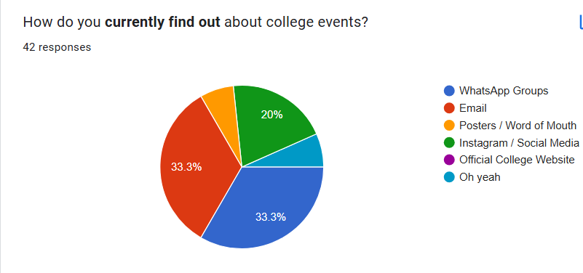
The data shows that no single platform serves as the primary source of event information.
Event announcements are scattered across multiple channels, leading to confusion and missed opportunities.
This fragmentation validates the need for a unified, centralized platform like Uniconnect that consolidates event listings and notifications in one place.
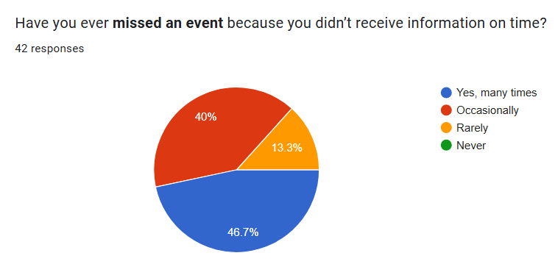
Based on the pie chart, a significant majority of the 42 respondents have missed an event due to untimely information. Specifically, 46.7% reported missing events "Yes, many times," and another 40% stated they missed events "Occasionally." This means that 86.7% of respondents experience this issue with some frequency. Only a small fraction—13.3%—reported that this happens "Rarely," and 0% reported "Never." This data strongly suggests a critical need for improvement in timely and effective information dissemination to ensure participation in events.
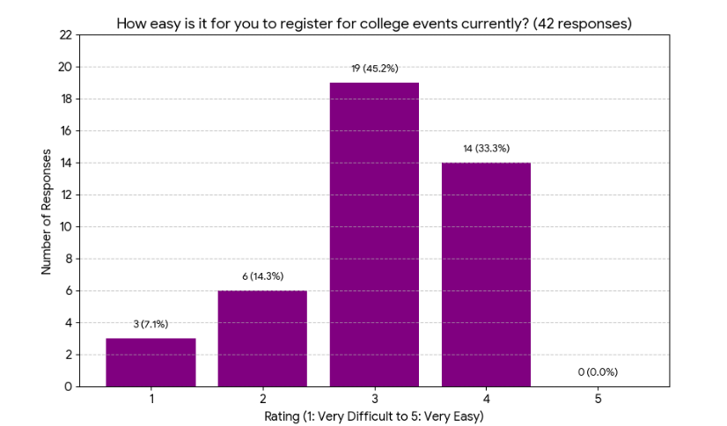
The largest group, (19 respondents), rated the ease of registration as '3' (Neutral/Moderate). This indicates that while the system functions, it lacks the intuitive ease desired by users. Critically, a combined (9 respondents) rated the process as '1' or '2' (Difficult or Very Difficult), underscoring that barriers to registration exist for a significant minority. Conversely, only (14 respondents) found the process '4' or '5' (Easy or Very Easy). This distribution reaffirms the need for strategic improvements to streamline the registration workflow and enhance user experience, moving a substantial portion of the currently at '3' into the '4' and '5' categories.
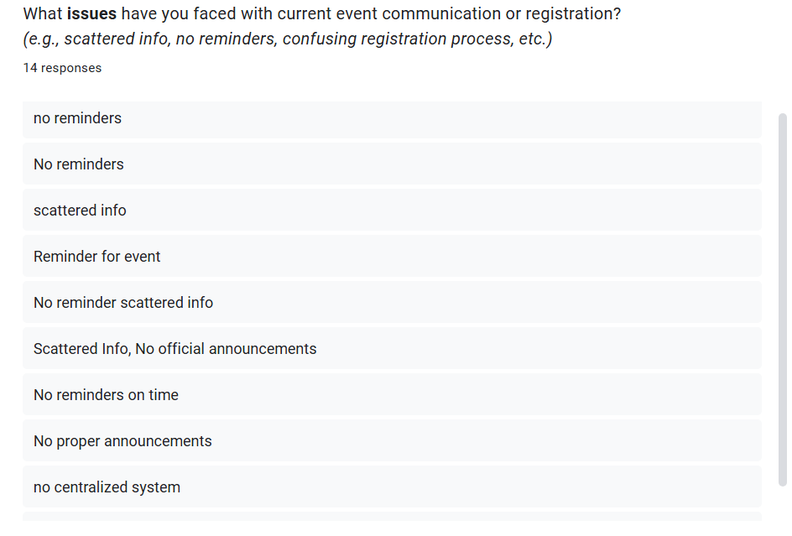
The open-ended responses decisively validate the need for a solution, pinpointing the two core systemic failures responsible for the missed events and difficult registration: a pervasive lack of "reminders" and the debilitating issue of "scattered info" with "no centralized system." This chaotic and non-automated communication structure, coupled with the fact that over two-thirds of students find the subsequent registration process either difficult or only moderate, confirms an acute and urgent need for a single, integrated platform to centralize event information, automate timely notifications, and provide a seamless registration experience.
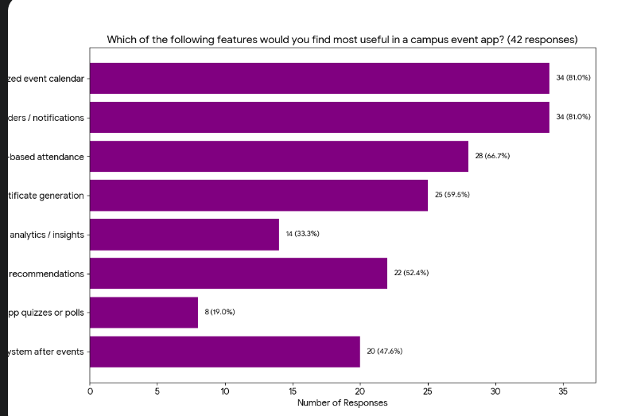
The two most desired features are a Centralized event calendar and Event reminders/notifications, both selected by of respondents. This absolute preference validates the need to directly address the primary failures of "scattered info" and "no reminders." High secondary demand exists for utility features that automate processes: QR-based attendance () and Automated certificate generation (). Therefore, the application's core functionality must immediately focus on a centralized communication hub combined with streamlined administrative tools to overcome the current barriers to student engagement.
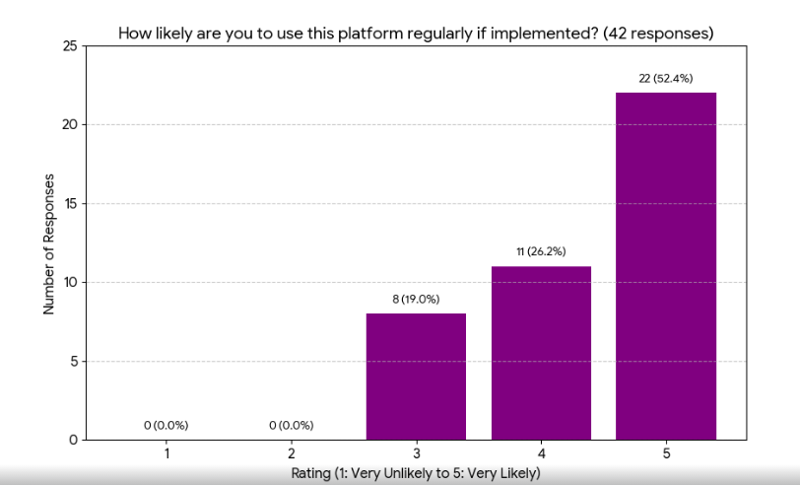
The final chart demonstrates overwhelming student receptiveness to the proposed solution, confirming the high demand identified throughout the survey. A combined of respondents rated their likelihood of using the platform regularly as '4' (Likely) or '5' (Very Likely), with the majority () selecting the highest rating. Crucially, of respondents indicated they would be unlikely to use the platform (ratings of '1' or '2'). This strong endorsement confirms that a platform offering the desired features (centralized communication and automated reminders) will effectively meet the existing need and will be adopted by the student body, virtually guaranteeing its relevance and utilization if implemented.
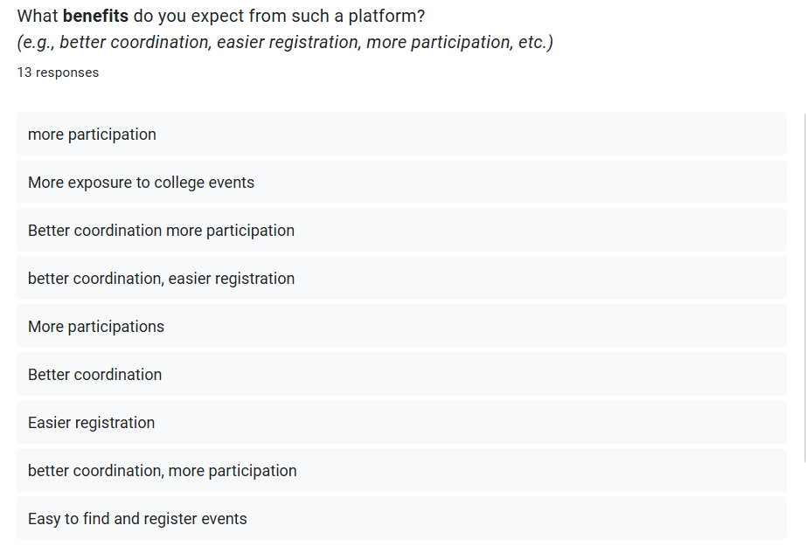
The most frequently cited desired outcome is "more participation" (mentioned multiple times), which is the ultimate goal of solving the initial problem of missed events. The expected mechanisms for achieving this are "better coordination" (organizational efficiency) and "easier registration" (reducing process friction), both of which were directly requested as the top features (Centralized Calendar, Event Reminders, and QR Attendance). Additionally, the need for "More exposure to college events" and "Easy to find and register events" reinforces the demand for a single, centralized platform. In essence, students believe that by implementing a system focused on communication (exposure/coordination) and usability (easier registration), the platform will successfully deliver the primary benefit of significantly increased event participation.

Problem Validation: Connecting Data to the Core Need
The survey findings decisively validate the problem, transitioning the project from a theoretical idea to a data-driven necessity. The core issue—students missing events due to poor communication and process friction—was confirmed by an overwhelming of respondents who admitted missing events because information wasn't received on time. This structural failure is explicitly defined by qualitative data citing "scattered info," "no reminders," and the critical absence of a "centralized system." This chaotic environment then feeds into the second major pain point: process friction, where the current registration system is found to be only 'Moderate' or outright 'Difficult' by a combined of the student body. In response, students overwhelmingly demanded the solution's core features—Centralized event calendar and Event reminders/notifications (both at )—and indicated high certainty of regular use ( rated 'Likely' or 'Very Likely'). Therefore, the proposed system is not merely an improvement but a validated, high-demand solution directly targeting the college's most pressing communication and administrative failures.

Summary :
Based on the quantitative and qualitative feedback, it is evident that the existing event management ecosystem suffers from severe deficiencies in communication reliability and process usability. The proposed platform is a verified necessity that will bridge this gap by offering a unified, centralized solution that simplifies event discovery and participation, while simultaneously providing the automated administrative tools needed for better coordination and efficient management across all institutional stakeholders.

